COSC 4333: Distributed Systems
Assignment 4
Due: 10:00am, Oct. 25, 2024 (Friday)

Name: ____Andrew Kalathra_______

LUID: ____L20498001_____

Date: ______10/25/2024______

(30 points)1. How to solve the totally ordered multicast problem based on Lamport’s logical clocks? You may use the following problem discussed in the class to illustrate your solution.
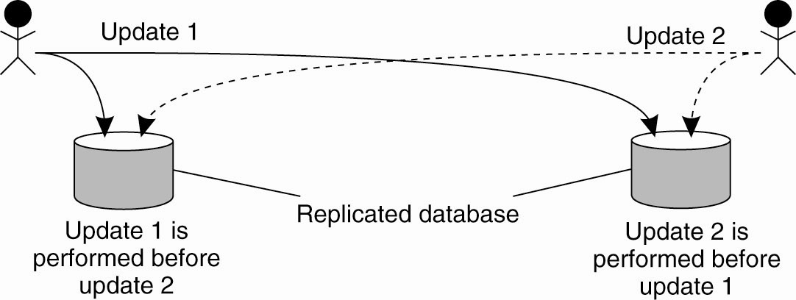
Your solution should be based on the following figure and provide more details than the textbook.
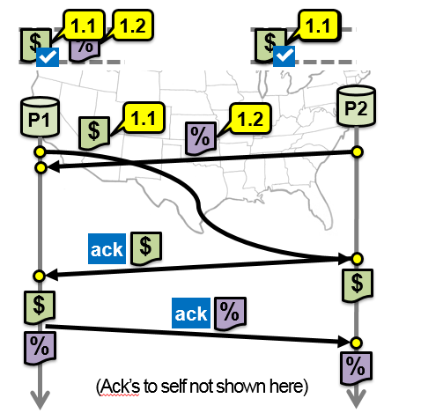
- As with most things, we can best explain the solution through an example.
- Suppose we have 2 different databases, each being accessed separately at (coincidentally) the same time, each with their own instructions.
- Let us label the events: $ and %. At database P1, we can see that $ happens, and that at P2, % happens.
  - P1: broadcasts event $ to everyone
  - P1: $ is added to the queue, it is now at the head of the queue, so and ack for $ is sent to everyone.
  - P2: broadcast event % to everyone
  - P2: receives $, so it is added to the queue, it is now at the head of the queue.
  - P2: % is added to the queue
  - P2: sends and ack for $ to everyone
  - P1: receives % and adds it to the queue
  - P1: receives the ack for $ from P2. As such, it dequeues $ and processes the request
  - P1: % is now at the head of the queue, so an ack for % is sent
  - P2: receives P1’s ack for $, P2 dequeues $ and processes the event, % is at the head of the queue.
  - P2: sends ack for % to everyone.
  - P2: receives P1’s ack for %.
  - P2: dequeues % and processes the event.
  - P1: receives P2’s ack for %, P1 dequeues % and processes the event

(30 points) 2. How to use vector clocks to enforce causally ordered multicasting? You may use the following problem discussed in the class as the example to illustrate your solution.

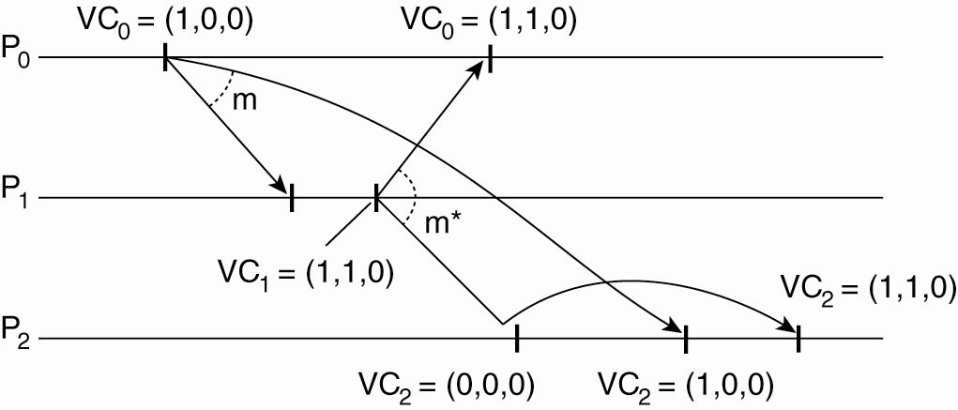
- Vector clocks keep logical times of each process. So, each spot in a vector holds the time of a process by counting the events that have occurred. In this case, the locations are <P₀, P₁, P₂,>, and these locations are held constant across all the processes.
- Let us walk through the example shown above:
  - P0: Sends out a post: <1, 0, 0>
  - P1: Receives P0’s post: <1, 0, 0>
  - P1: Sends out a post: <1, 1, 0>
  - P2: Receives P1’s post, but when comparing its own <0, 0, 0> to what was sent by P1 <1, 1, 0>, realizes it must wait from an event occurring from P0.
  - P0: Receives P1’s post: <1, 1, 0>
  - P2: Receives P0’s post: <1, 0, 0>
  - P2: After update from P0 that it was waiting for, then receives P1’s post: <1, 1, 0>

(40 points) This question is about RPC implementation. Please watch the video “RPC Example Programming” before you do it.
Please implement the following two procedures at the server side:
1.int Sum(int n): compute the sum 1+2+…n;
2.int Fib (n): return the nth term in the Fibonacci sequence. The Fibonacci sequence is a series of numbers where a number is the addition of the last two numbers, starting with 0, and 1. The Fibonacci Sequence: 0, 1, 1, 2, 3, 5, 8, 13, 21, 34, 55…
Written as a rule, the expression is:
Xn = Xn-1 + Xn-2
At the client side:
- The client accepts one positive integer N as the input;
- The client then passes this integer N to the server through RPC;
- The server accepts N, and invoke Sum(N) and Fib(N), and return the result to the client through RPC;
- The client prints out the result of Sum(N) and Fib(N).
Please submit all your source code based on C programming language.
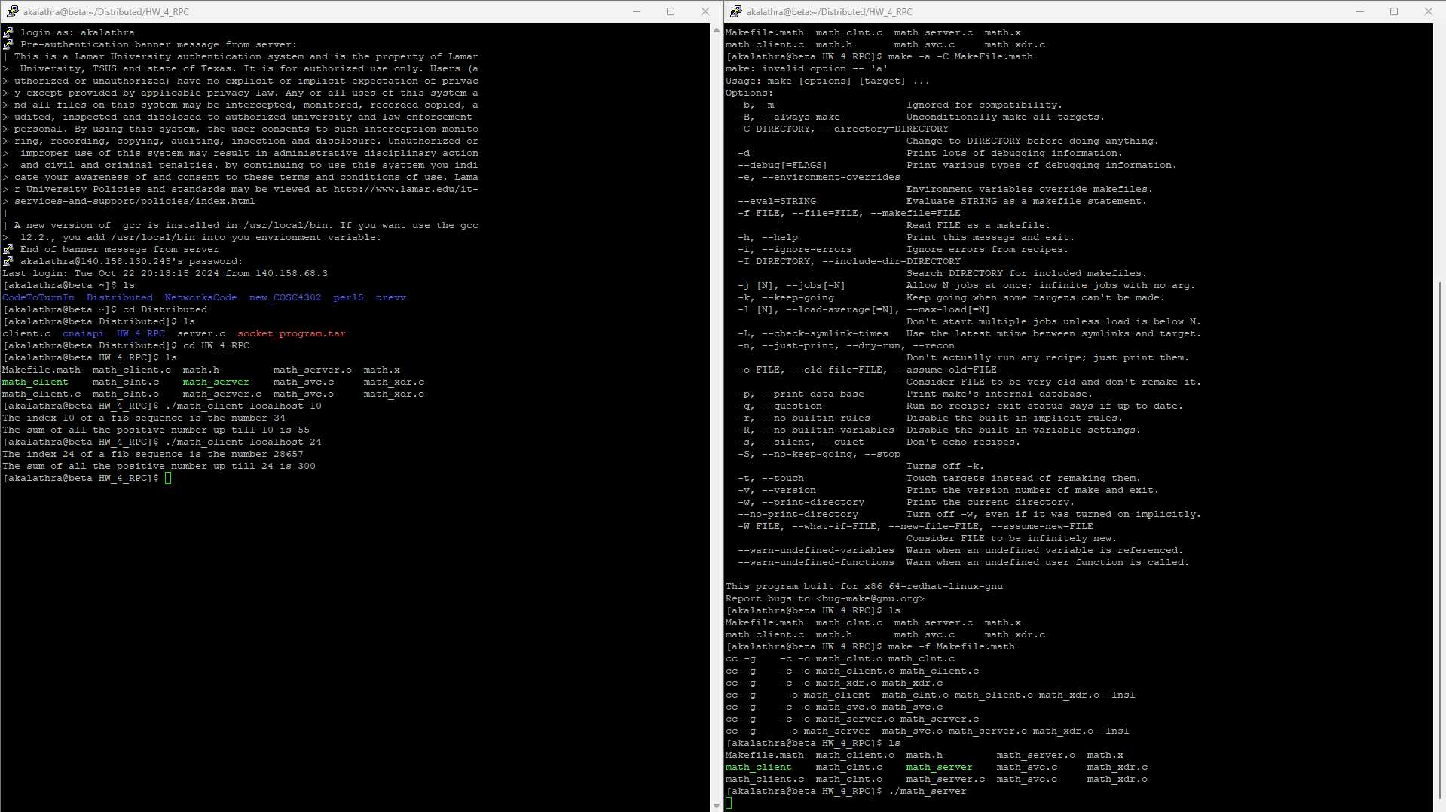
How to Turn In:
Softcopy: Please use BlackBoard to turn in your homework solutions.
- I will just turn in the client and server, and will leave the rest of the files in a zipped folder.

